Docker Assignment-1
One GitHub repository has three different branches containing index.html files. These are deployed in an httpd container using a Jenkins pipeline script. Jobs are created on the Jenkins Master (JM).

Architecture
- 1 GitHub repository
- 3 branches:
  - dev
  - test
  - qa
- Each branch contains:
  - index.html
- Jenkins Master (JM) creates jobs
Git
Docker
Httpd container
- Pipeline deploys:
  - DEV → port 8081
  - TEST → port 8082
  - qa → port 8083
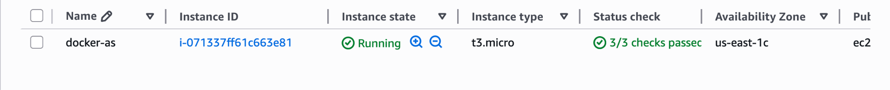

Docker job
pipeline {
agent any
environment {
REPO_URL = "https://github.com/saraswatilamture/Docker-assignment-1.git"
}
stages {
stage('Clean Workspace') {
steps {
cleanWs()
}
}
stage('Pull Apache Image') {
steps {
sh 'docker pull httpd'
}
}
stage('Deploy DEV Branch') {
steps {
sh '''
git clone -b dev $REPO_URL devrepo
chmod 644 devrepo/index.html
docker rm -f c1 || true
docker run -d --name c1 -p 80:80 httpd
docker cp devrepo/index.html c1:/usr/local/apache2/htdocs/index.html
docker exec c1 chmod 755 /usr/local/apache2/htdocs
docker exec c1 chmod 644 /usr/local/apache2/htdocs/index.html
'''
}
}
stage('Deploy TEST Branch') {
steps {
sh '''
git clone -b test $REPO_URL testrepo
chmod 644 testrepo/index.html
docker rm -f c2 || true
docker run -d --name c2 -p 90:80 httpd
docker cp testrepo/index.html c2:/usr/local/apache2/htdocs/index.html
docker exec c2 chmod 755 /usr/local/apache2/htdocs
docker exec c2 chmod 644 /usr/local/apache2/htdocs/index.html
'''
}
}
stage('Deploy QA Branch') {
steps {
sh '''
git clone -b qa $REPO_URL qarepo
chmod 644 qarepo/index.html
docker rm -f c3 || true
docker run -d --name c3 -p 8082:80 httpd
docker cp qarepo/index.html c3:/usr/local/apache2/htdocs/index.html
docker exec c3 chmod 755 /usr/local/apache2/htdocs
docker exec c3 chmod 644 /usr/local/apache2/htdocs/index.html
'''
}
}
}
post {
success {
echo "All branches deployed successfully."
}
failure {
echo "Pipeline failed."
}
}
}

